

**Signals and Systems**

Lab Report #06

# Name:

Taha Saeed

**Registration number:**

FA18-EEE-032

**Submitted to:**

Dr. Ghufran Shafiq

**In-Lab Tasks**

**Task 01: Compute and plot the convolution by any of the two procedures, where**

** and **

**Solution:**

n1=[-5:1:5];

H=n1>=1;

Hn=double(H);

subplot(3,1,1)

stem(n1,Hn);

title('Hn');

n2=[-5:1:5];

U=n2<=-1;

Un=double(U);

X=(1/3).^(-n2);

Xn=X.*Un;

subplot(3,1,2)

stem(n2,Xn);

title('Xn');

Y=conv(Xn,Hn);

%book wala wala formula l=length(Xn)+length(Hn)-1;

%youtube wala formula n=n1(1)+n2(1):n1(end)+n2(end);

n=n1(1)+n2(1):n1(end)+n2(end);

subplot(3,1,3)

stem(n,Y);

title('Y');

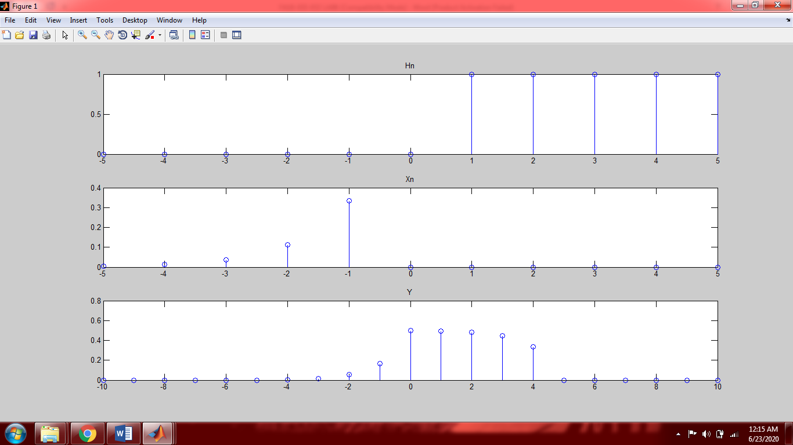

**Task 02: Compute and plot the convolution of following signals (by both procedures)**



and



**Method 1:**

n1=[-1:1:10];

Xn=((n1>=0)&(n1<=4));

Xn=double(Xn);

subplot(3,1,1);

stem(n1,Xn);

title('X[n]');

n2=[-1:1:10];

H1=(1.5).^n2;

Hn=H1.*((n2>=0)&(n2<=6));

subplot(3,1,2);

stem(n2,Hn);

title('H[n]');

Yn=conv(Xn,Hn);

n=n1(1)+n2(1):n1(end)+n2(end);

subplot(3,1,3);

stem(n,Yn);

title('Y[n]');

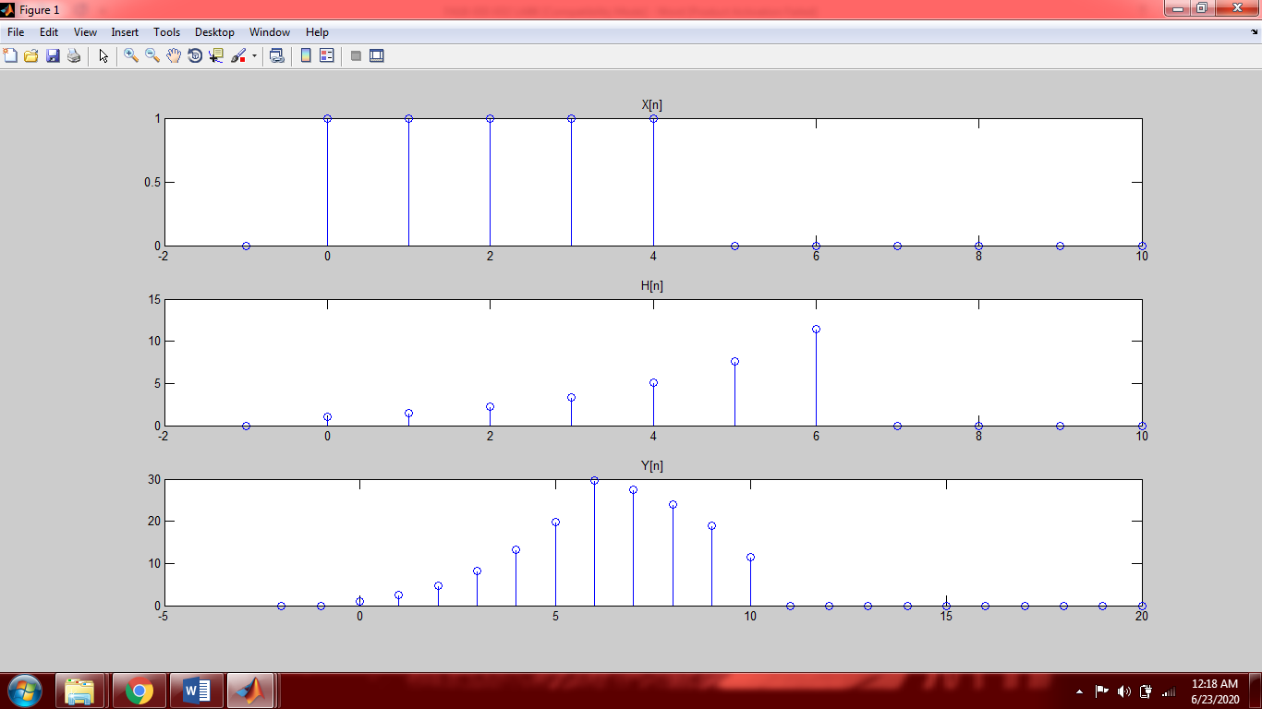

**Method 2:**

n1=[0:1:6];

Xn=((n1>=0)&(n1<=4));

Xn=double(Xn);

figure(1);

subplot(3,1,1);

stem(n1,Xn);

title('X[n]');

n2=[0:1:6];

H1=(1.5).^n2;

Hn=H1.*((n2>=0)&(n2<=6));

subplot(3,1,2);

stem(n2,Hn);

title('H[n]');

Xn=((n1<=0)&(n1>=-4));

Xn=double(Xn);

subplot(3,1,3);

stem(n1,Xn);

title('X[-k]');

Xn=((n1<=0)&(n1>=-4));

Xn=double(Xn);

figure(2);

subplot(4,3,1);

stem(n1,Xn);

title('X[-k+0]');

M0=Xn.*Hn;

S0=sum(M0);

Xn=((n1<=1)&(n1>=-3));

Xn=double(Xn);

subplot(4,3,2);

stem(n1,Xn);

title('X[-k+1]');

M1=Xn.*Hn;

S1=sum(M1);

Xn=((n1<=2)&(n1>=-2));

Xn=double(Xn);

subplot(4,3,3);

stem(n1,Xn);

title('X[-k+2]');

M2=Xn.*Hn;

S2=sum(M2);

Xn=((n1<=3)&(n1>=-1));

Xn=double(Xn);

subplot(4,3,4);

stem(n1,Xn);

title('X[-k+3]');

M3=Xn.*Hn;

S3=sum(M3);

Xn=((n1<=4)&(n1>=0));

Xn=double(Xn);

subplot(4,3,5);

stem(n1,Xn);

title('X[-k+4]');

M4=Xn.*Hn;

S4=sum(M4);

Xn=((n1>=1)&(n1<=5));

Xn=double(Xn);

subplot(4,3,6);

stem(n1,Xn);

title('X[-k+5]');

M5=Xn.*Hn;

S5=sum(M5);

Xn=((n1>=2)&(n1<=6));

Xn=double(Xn);

subplot(4,3,7);

stem(n1,Xn);

title('X[-k+6]');

M6=Xn.*Hn;

S6=sum(M6);

Xn=((n1>=3)&(n1<=7));

Xn=double(Xn);

subplot(4,3,8);

stem(n1,Xn);

title('X[-k+7]');

M7=Xn.*Hn;

S7=sum(M7);

Xn=((n1>=4)&(n1<=8));

Xn=double(Xn);

subplot(4,3,9);

stem(n1,Xn);

title('X[-k+8]');

M8=Xn.*Hn;

S8=sum(M8);

Xn=((n1>=5)&(n1<=9));

Xn=double(Xn);

subplot(4,3,10);

stem(n1,Xn);

title('X[-k+9]');

M9=Xn.*Hn;

S9=sum(M9);

Xn=((n1>=6)&(n1<=10));

Xn=double(Xn);

subplot(4,3,11);

stem(n1,Xn);

title('X[-k+10]');

M10=Xn.*Hn;

S10=sum(M10);

Xn=((n1>=7)&(n1<=11));

Xn=double(Xn);

subplot(4,3,12);

stem(n1,Xn);

title('X[-k+11]');

M11=Xn.*Hn;

S11=sum(M11);

Y=[S0 S1 S2 S3 S4 S5 S6 S7 S8 S9 S10 S11];

figure(3);

stem(0:11,Y);

title('Y[n] final answer');

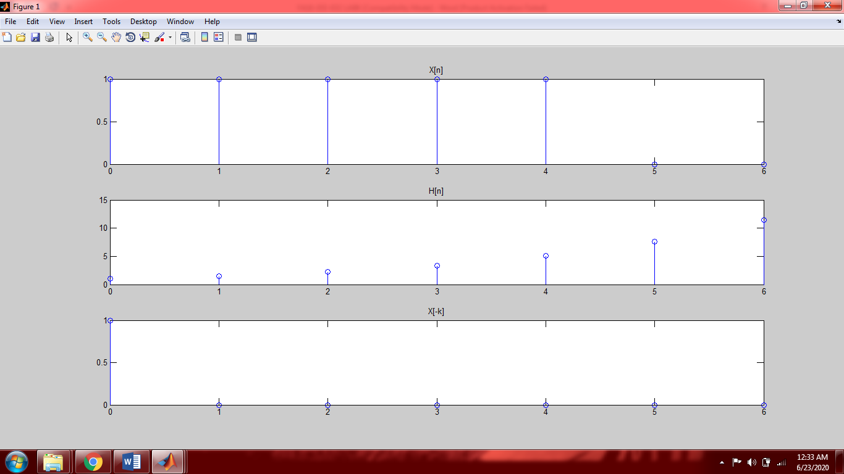

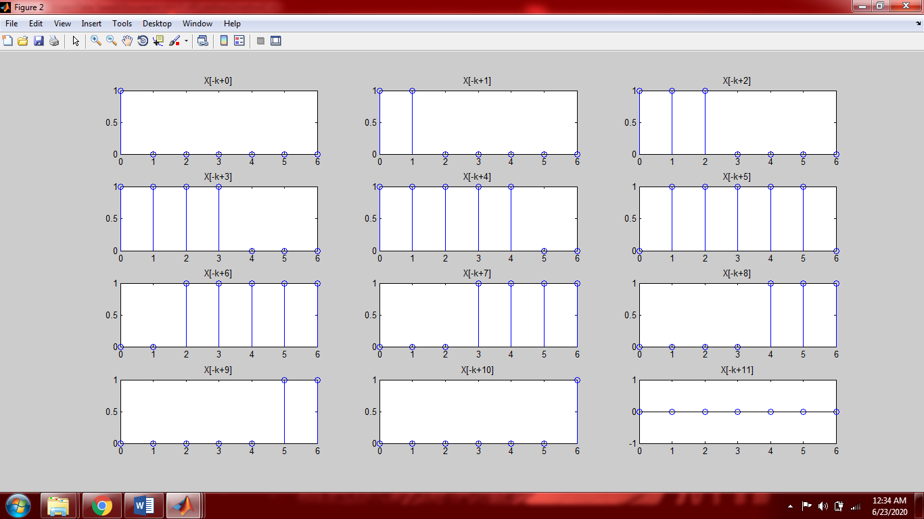

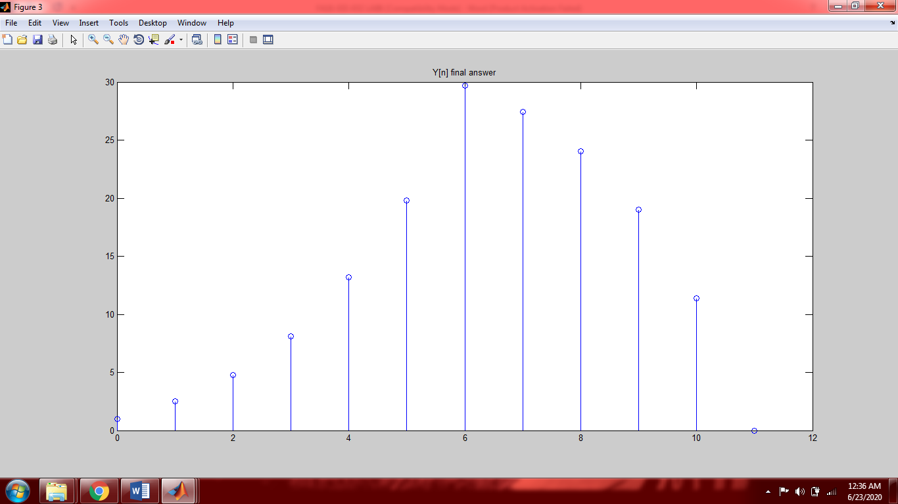

**Task 03: Consider and LTI system with input  and unit impulse response  specified as**





**Compute the response of the system (by both methods) where we have .**

**Method 1:**

n1=[-6:1:6];

H=n1>=0;

Hn=double(H);

subplot(3,1,1);

stem(n1,Hn);

title('H[n]');

n2=[-6:1:6];

U=n2<=0;

Un=double(U);

X1=2.^n2;

Xn=X1.*Un;

subplot(3,1,2);

stem(n2,Xn);

title('Xn');

Y=conv(Xn,Hn);

l=n1(1)+ n2(1):n1(end)+n2(end);

subplot(3,1,3);

stem(l,Y);

title('Y[n]');

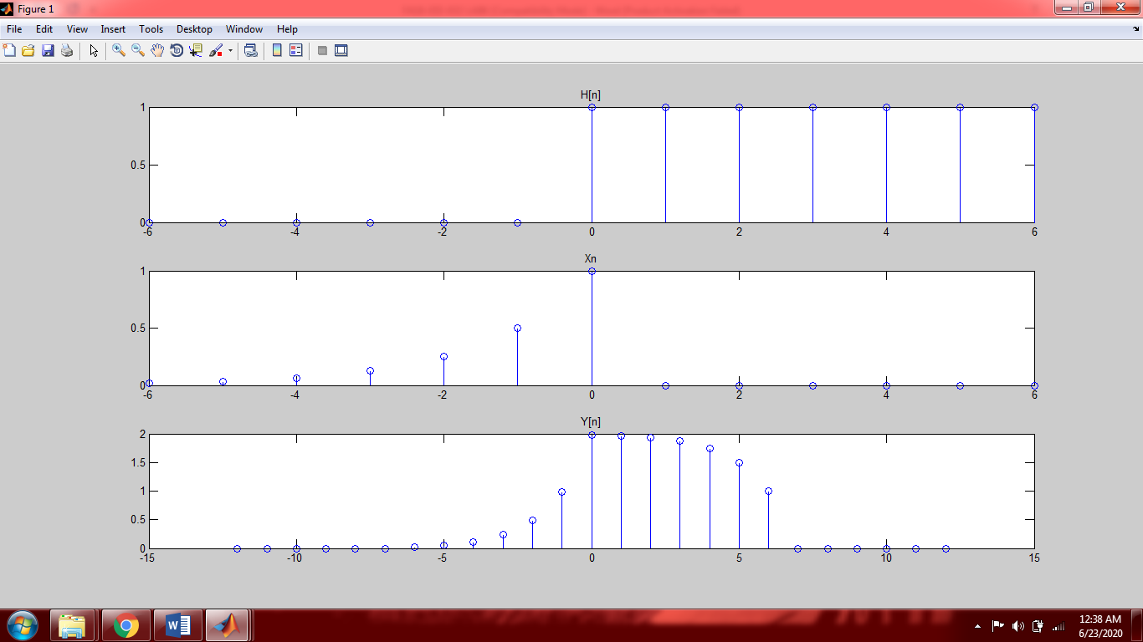

**Method 2:**

n1=[-6:1:6];

H=n1>=0;

Hn=double(H);

figure(1);

subplot(5,3,1);

stem(n1,Hn);

title('H[n]');

n2=[-6:1:6];

U=n2<=0;

Un=double(U);

X1=2.^n2;

Xn=X1.*Un;

subplot(5,3,2);

stem(n2,Xn);

title('Xn');

H=n1<=0;

Hn=double(H);

subplot(5,3,3);

stem(n1,Hn);

title('H[-k] flipped signal');

H=n1<=0+0;

Hn=double(H);

subplot(5,3,4);

stem(n1,Hn);

title('H[-k+0]');

M0=Hn.*Xn;

S0=sum(M0);

H=(n1<=0+1)&(n1>-6);

Hn=double(H);

subplot(5,3,5);

stem(n1,Hn);

title('H[-k+1]');

M1=Hn.*Xn;

S1=sum(M1);

H=(n1<=0+2)&(n1>-5);

Hn=double(H);

subplot(5,3,6);

stem(n1,Hn);

title('H[-k+2]');

M2=Hn.*Xn;

S2=sum(M2);

H=(n1<=0+3)&(n1>-4);

Hn=double(H);

subplot(5,3,7);

stem(n1,Hn);

title('H[-k+3]');

M3=Hn.*Xn;

S3=sum(M3);

H=(n1<=0+4)&(n1>-3);

Hn=double(H);

subplot(5,3,8);

stem(n1,Hn);

title('H[-k+4]');

M4=Hn.*Xn;

S4=sum(M4);

H=(n1<=0+5)&(n1>-2);

Hn=double(H);

subplot(5,3,9);

stem(n1,Hn);

title('H[-k+5]');

M5=Hn.*Xn;

S5=sum(M5);

H=n1>=0;

Hn=double(H);

subplot(5,3,10);

stem(n1,Hn);

title('H[-k+6]');

M6=Hn.*Xn;

S6=sum(M6);

H=n1>=1;

Hn=double(H);

subplot(5,3,11);

stem(n1,Hn);

title('H[-k+7]');

M7=Hn.*Xn;

S7=sum(M7);

H=n1>=2;

Hn=double(H);

subplot(5,3,12);

stem(n1,Hn);

title('H[-k+8]');

M8=Hn.*Xn;

S8=sum(M8);

H=n1>=3;

Hn=double(H);

subplot(5,3,13);

stem(n1,Hn);

title('H[-k+9]');

M9=Hn.*Xn;

S9=sum(M9);

H=n1>=4;

Hn=double(H);

subplot(5,3,14);

stem(n1,Hn);

title('H[-k+10]');

M10=Hn.*Xn;

S10=sum(M10);

H=n1>=5;

Hn=double(H);

subplot(5,3,15);

stem(n1,Hn);

title('H[-k+11]');

M11=Hn.*Xn;

S11=sum(M11);

H=n1>=6;

Hn=double(H);

figure(2);

stem(n1,Hn);

title('H[-k+12]');

M12=Hn.*Xn;

S12=sum(M12);

Y=[S0 S1 S2 S3 S4 S5 S6 S7 S8 S9 S10 S11 S12];

figure(3);

stem(0:12,Y);

title('Y[n] final ans');

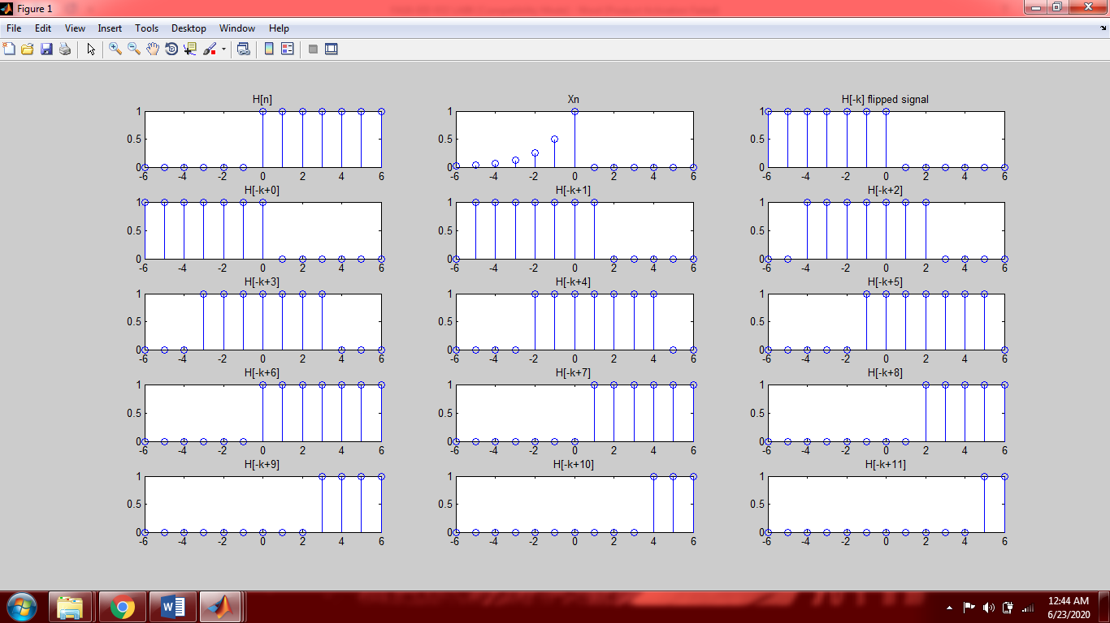

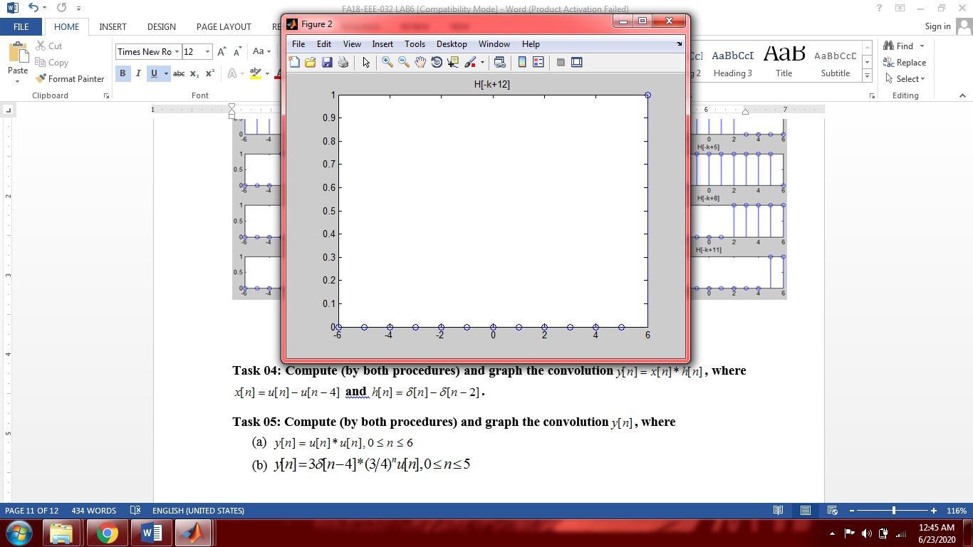

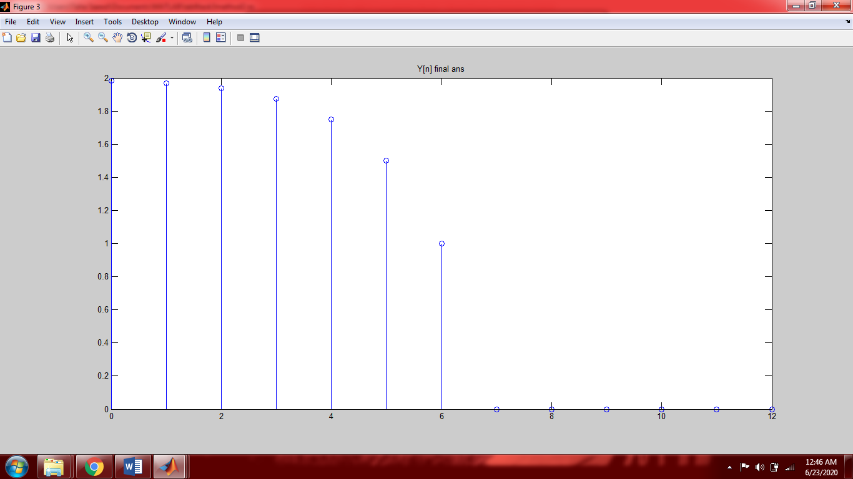

**Task 04: Compute (by both procedures) and graph the convolution, where  and .**

**Method 1:**

n1=[-1:1:6];

u1=n1>=0;

u2=n1>=4;

Un=u1-u2;

subplot(3,1,1);

stem(n1,Un);

title('X[n]');

n2=[-1:1:6];

h1=n2==0;

h2=n2==2;

Hn=h1-h2;

subplot(3,1,2);

stem(n2,Hn);

title('H[n]');

Y=conv(Un,Hn);

l=n1(1)+n2(1):n1(end)+n2(end);

subplot(3,1,3);

stem(l,Y);

title('Y[n]');

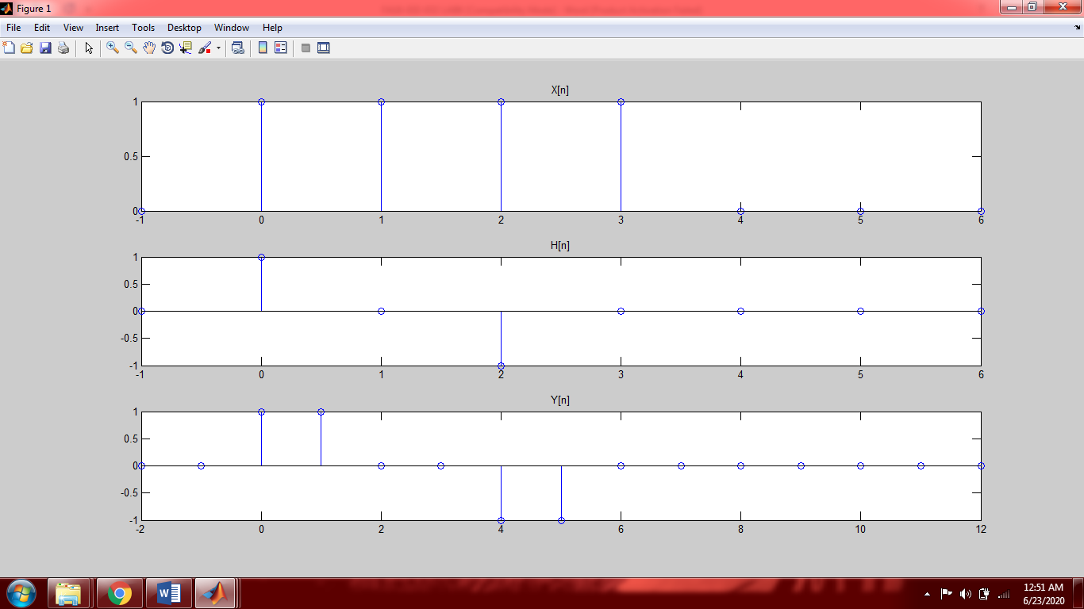

**Method 2:**

n1=[0:1:6];

u1=n1>=0;

u2=n1>=4;

Un=u1-u2;

figure(1);

subplot(3,1,1);

stem(n1,Un);

title('X[n]');

n2=[0:1:6];

h1=n2==0;

h2=n2==2;

Hn=h1-h2;

subplot(3,1,2);

stem(n2,Hn);

title('H[n]');

Un=(n1<=0)&(n1>=-3);

figure(1);

subplot(3,1,3);

stem(n1,Un);

title('X[-k]');

Un=(n1<=0)&(n1>=-3);

figure(2);

subplot(4,3,1);

stem(n1,Un);

title('X[-k+0]');

M0=Un.*Hn;

S0=sum(M0);

Un=(n1<=1)&(n1>=-2);

figure(2);

subplot(4,3,2);

stem(n1,Un);

title('X[-k+1]');

M1=Un.*Hn;

S1=sum(M1);

Un=(n1<=2)&(n1>=-1);

figure(2);

subplot(4,3,3);

stem(n1,Un);

title('X[-k+2]');

M2=Un.*Hn;

S2=sum(M2);

Un=(n1<=3)&(n1>=0);

figure(2);

subplot(4,3,4);

stem(n1,Un);

title('X[-k+3]');

M3=Un.*Hn;

S3=sum(M3);

Un=(n1>=1)&(n1<=4);

figure(2);

subplot(4,3,5);

stem(n1,Un);

title('X[-k+4]');

M4=Un.*Hn;

S4=sum(M4);

Un=(n1>=2)&(n1<=5);

figure(2);

subplot(4,3,6);

stem(n1,Un);

title('X[-k+5]');

M5=Un.*Hn;

S5=sum(M5);

Un=(n1>=3)&(n1<=6);

figure(2);

subplot(4,3,7);

stem(n1,Un);

title('X[-k+6]');

M6=Un.*Hn;

S6=sum(M6);

Un=(n1>=4)&(n1<=7);

figure(2);

subplot(4,3,8);

stem(n1,Un);

title('X[-k+7]');

M7=Un.*Hn;

S7=sum(M7);

Un=(n1>=5)&(n1<=8);

figure(2);

subplot(4,3,9);

stem(n1,Un);

title('X[-k+8]');

M8=Un.*Hn;

S8=sum(M8);

Un=(n1>=6)&(n1<=9);

figure(2);

subplot(4,3,10);

stem(n1,Un);

title('X[-k+9]');

M9=Un.*Hn;

S9=sum(M9);

Y=[S0 S1 S2 S3 S4 S5 S6 S7 S8 S9]

figure(3)

stem(0:9,Y);

title('Y[n] final ans');

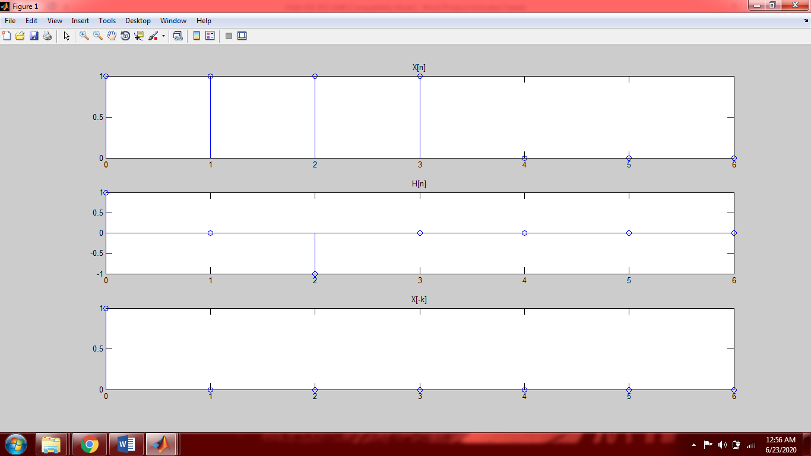

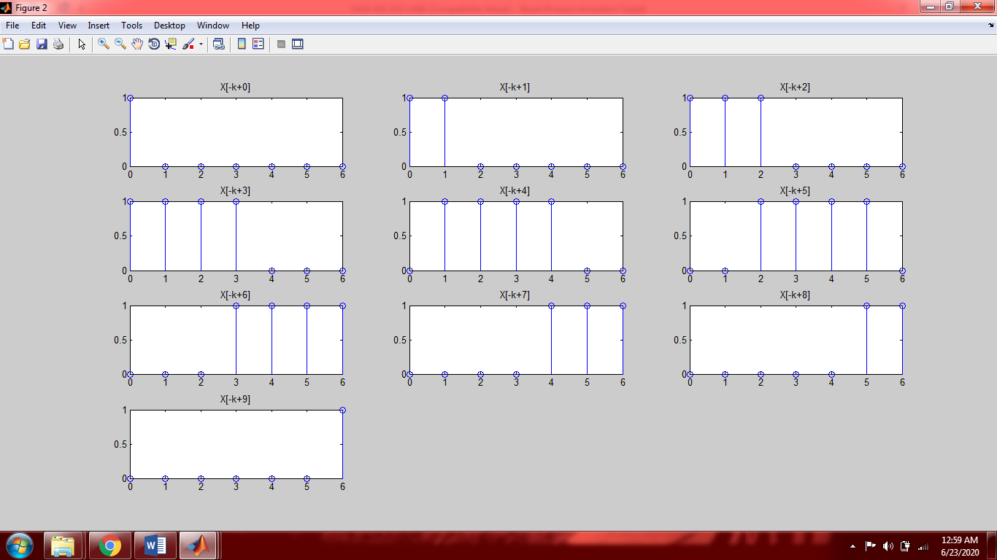

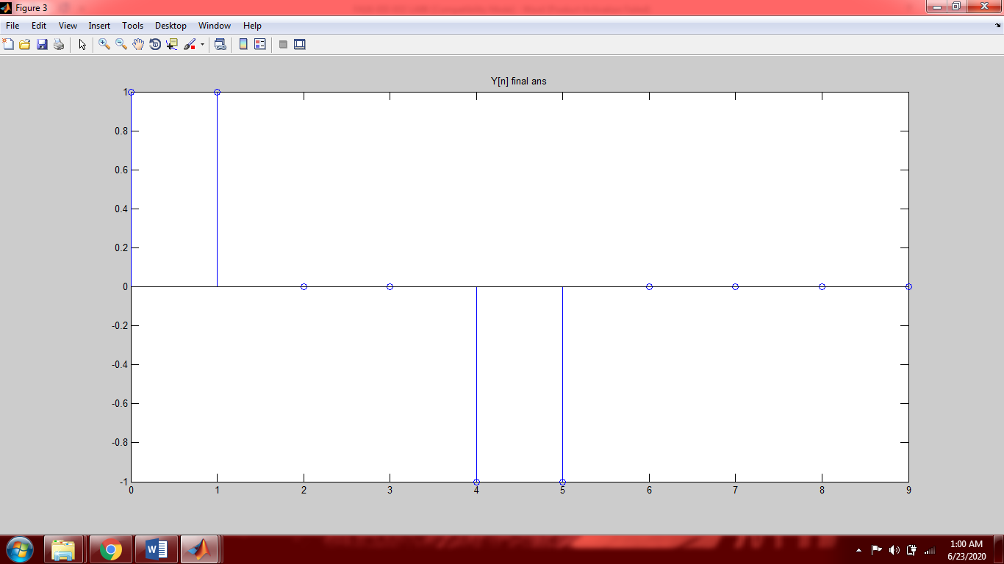

**Task 05: Compute (by both procedures) and graph the convolution, where**

1. 
2. 

**Task (a):**

**Method 1:**

n=[0:1:6];

U=n>=0;

Un=double(U);

subplot(2,1,1);

stem(n,Un);

title('U[N]');

Y=conv(Un,Un);

l=n(1)+n(1):n(end)+n(end);

subplot(2,1,2);

stem(l,Y);

title('Y[N]');

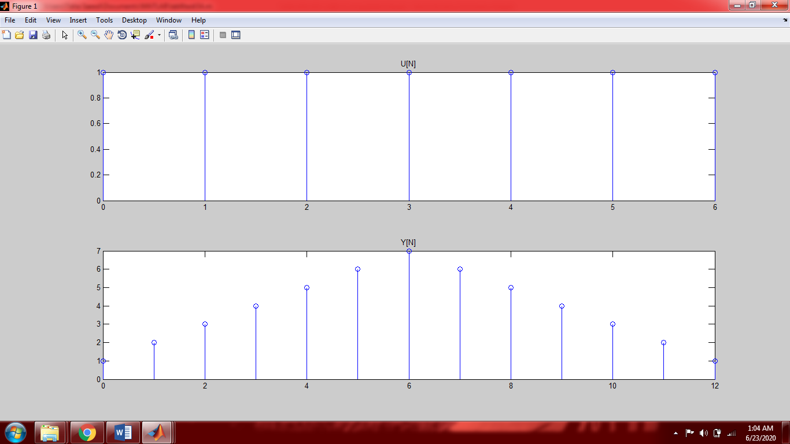

**Method 2:**

n=[0:1:6];

U=n>=0;

Un=double(U);

subplot(5,3,1);

stem(n,Un);

title('U[N]');

Zn=n<=0;

Zn=double(Zn);

subplot(5,3,2);

stem(n,Zn);

title('X[-k]');

Zn=n<=0+0;

Zn=double(Zn);

subplot(5,3,3);

stem(n,Zn);

title('X[-k+0]');

M0=Zn.*Un;

S0=sum(M0);

Zn=n<=0+1;

Zn=double(Zn);

subplot(5,3,4);

stem(n,Zn);

title('X[-k+1]');

M1=Zn.*Un;

S1=sum(M1);

Zn=n<=0+2;

Zn=double(Zn);

subplot(5,3,5);

stem(n,Zn);

title('X[-k+2]');

M2=Zn.*Un;

S2=sum(M2);

Zn=n<=0+3;

Zn=double(Zn);

subplot(5,3,6);

stem(n,Zn);

title('X[-k+3]');

M3=Zn.*Un;

S3=sum(M3);

Zn=n<=0+4;

Zn=double(Zn);

subplot(5,3,7);

stem(n,Zn);

title('X[-k+4]');

M4=Zn.*Un;

S4=sum(M4);

Zn=n<=0+5;

Zn=double(Zn);

subplot(5,3,8);

stem(n,Zn);

title('X[-k+5]');

M5=Zn.*Un;

S5=sum(M5);

Zn=n<=0+6;

Zn=double(Zn);

subplot(5,3,9);

stem(n,Zn);

title('X[-k+6]');

M6=Zn.*Un;

S6=sum(M6);

Zn=(n>=1)&(n<=6);

Zn=double(Zn);

subplot(5,3,10);

stem(n,Zn);

title('X[-k+7]');

M7=Zn.*Un;

S7=sum(M7);

Zn=(n>=2)&(n<=6);

Zn=double(Zn);

subplot(5,3,11);

stem(n,Zn);

title('X[-k+8]');

M8=Zn.*Un;

S8=sum(M8);

Zn=(n>=3)&(n<=6);

Zn=double(Zn);

subplot(5,3,12);

stem(n,Zn);

title('X[-k+9]');

M9=Zn.*Un;

S9=sum(M9);

Zn=(n>=4)&(n<=6);

Zn=double(Zn);

subplot(5,3,13);

stem(n,Zn);

title('X[-k+10]');

M10=Zn.*Un;

S10=sum(M10);

Zn=(n>=5)&(n<=6);

Zn=double(Zn);

subplot(5,3,14);

stem(n,Zn);

title('X[-k+11]');

M11=Zn.*Un;

S11=sum(M11);

Zn=(n>=6)&(n<=6);

Zn=double(Zn);

subplot(5,3,15);

stem(n,Zn);

title('X[-k+12]');

M12=Zn.*Un;

S12=sum(M12);

C=[S0 S1 S2 S3 S4 S5 S6 S7 S8 S9 S10 S11 S12];

figure(2);

stem(0:12,C);

title('Y[n]final ans');

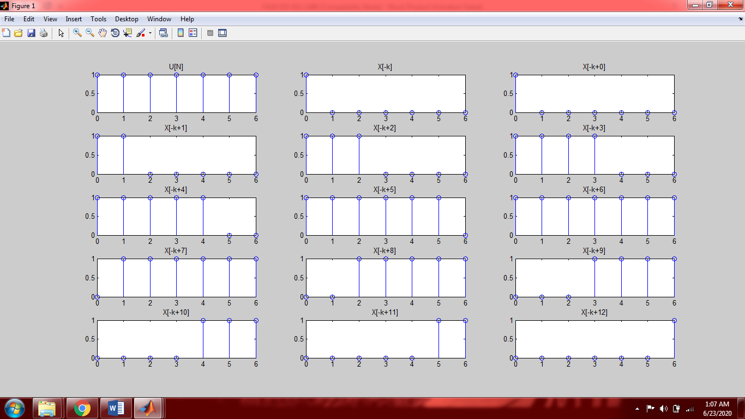

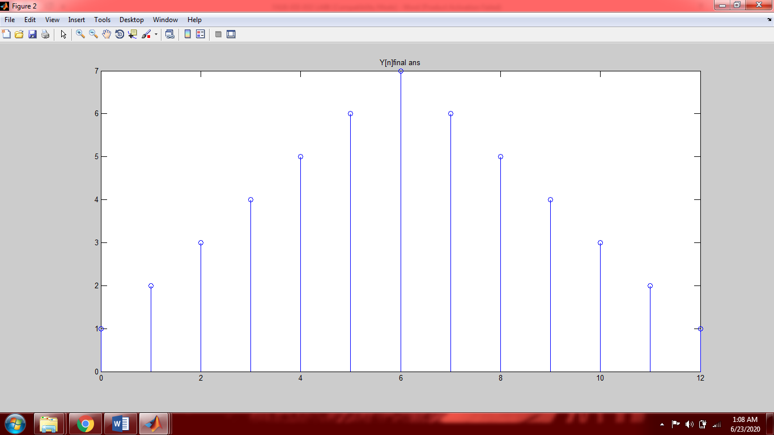

**Task (b):**

**Method 1:**

n=[0:1:5];

U=n>=0;

Un=double(U);

X1=(3/4).^n;

Xn=X1.*Un;

subplot(3,1,1);

stem(n,Xn);

title('X[n]');

h=n==4;

Hn=3.*h;

subplot(3,1,2);

stem(n,Hn);

title('H[n]');

Y=conv(Xn,Hn);

l=n(1)+n(1):n(end)+n(end);

subplot(3,1,3);

stem(l,Y);

title('Y[n]');

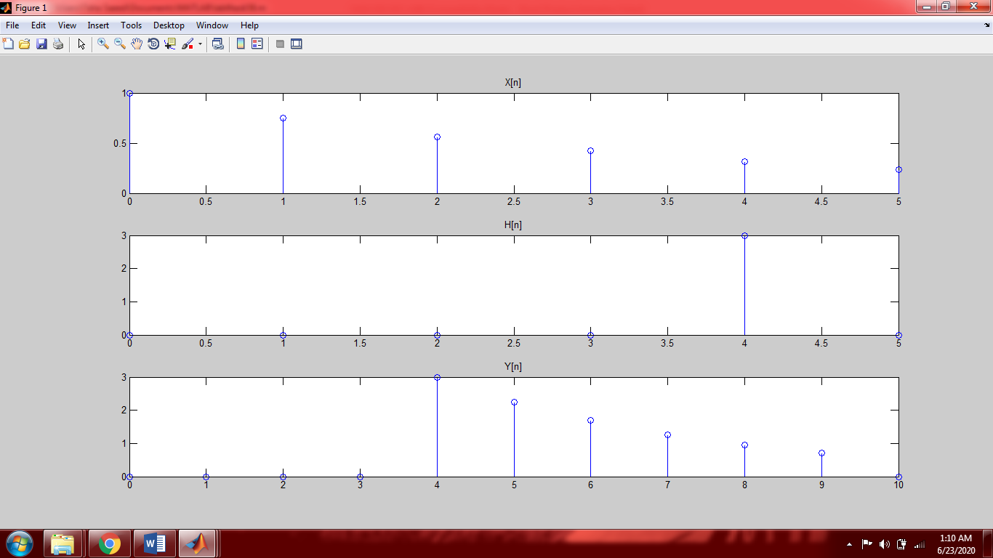

**Method 2:**

n=[0:1:5];

U=n>=0;

Un=double(U);

X1=(3/4).^n;

Xn=X1.*Un;

subplot(3,1,1);

stem(n,Xn);

title('X[n]');

h=n==4;

Hn=3.*h;

subplot(3,1,2);

stem(n,Hn);

title('H[n]');

h=n==-4;

Hn=3.*h;

subplot(3,1,3);

stem(n,Hn);

title('H[-k]');

%since n is from 0 to 5 the inverted signal will be out of frame

h=n==0;

Hn=3.*h;

figure(2)

subplot(3,2,1);

stem(n,Hn);

title('H[-k+0]');

M0=Hn.*Xn;

S0=sum(M0);

h=n==1;

Hn=3.*h;

figure(2)

subplot(3,2,2);

stem(n,Hn);

title('H[-k+1]');

M1=Hn.*Xn;

S1=sum(M1);

h=n==2;

Hn=3.*h;

figure(2)

subplot(3,2,3);

stem(n,Hn);

title('H[-k+2]');

M2=Hn.*Xn;

S2=sum(M2);

h=n==3;

Hn=3.*h;

figure(2)

subplot(3,2,4);

stem(n,Hn);

title('H[-k+3]');

M3=Hn.*Xn;

S3=sum(M3);

h=n==4;

Hn=3.*h;

figure(2)

subplot(3,2,5);

stem(n,Hn);

title('H[-k+4]');

M4=Hn.*Xn;

S4=sum(M4);

h=n==5;

Hn=3.*h;

figure(2)

subplot(3,2,6);

stem(n,Hn);

title('H[-k+5]');

M5=Hn.*Xn;

S5=sum(M5);

%since we know the first overlap takes place at 4 so from 0 to 3 the

%value of convoloution in 0

Y=[0 0 0 0 S0 S1 S2 S3 S4 S5 0];

figure(3);

stem(0:10,Y);

title('Y[n] final ans');

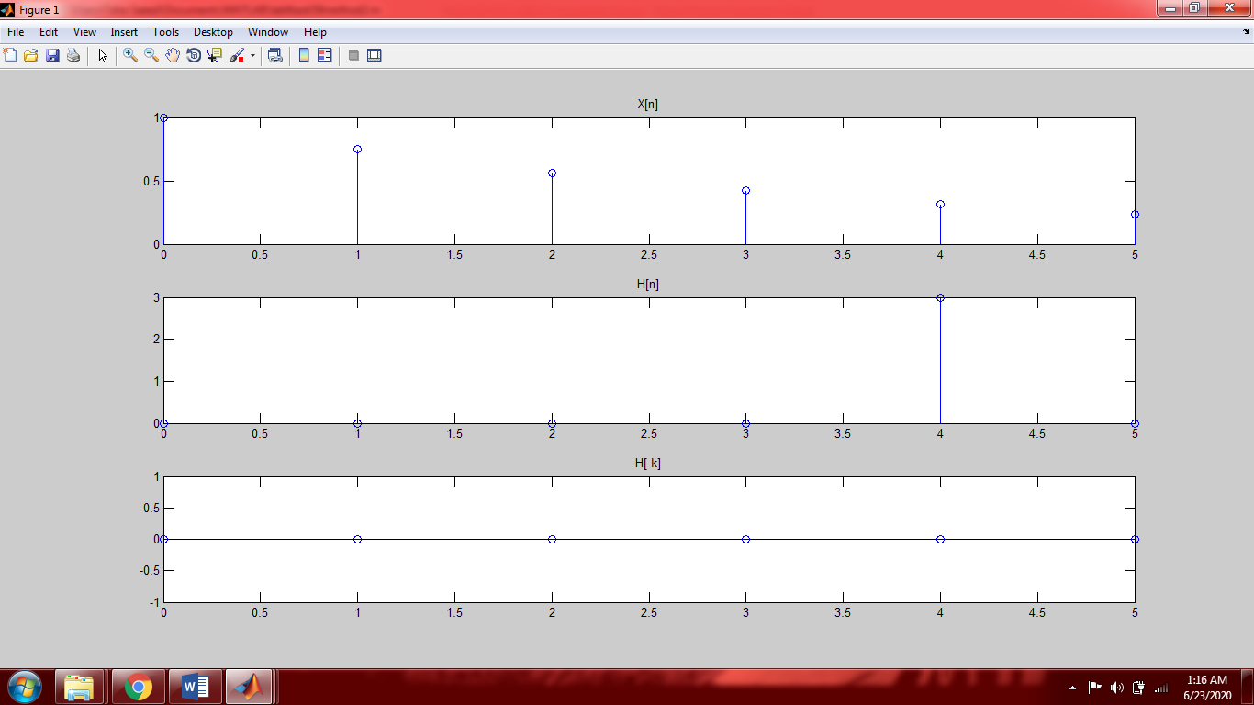

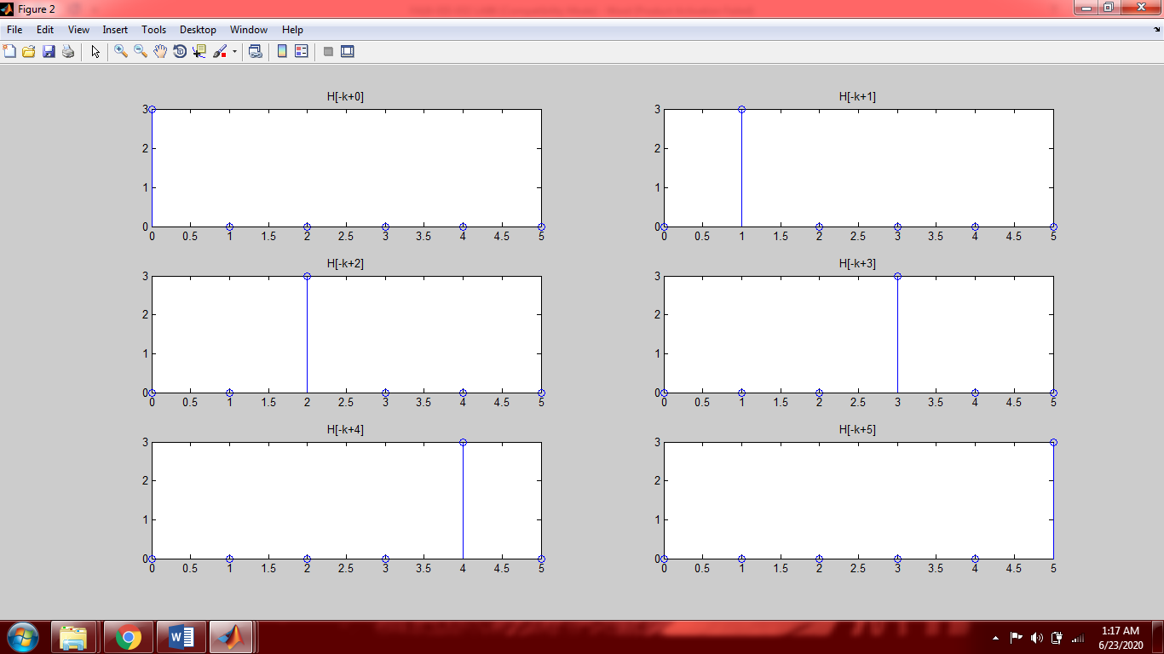

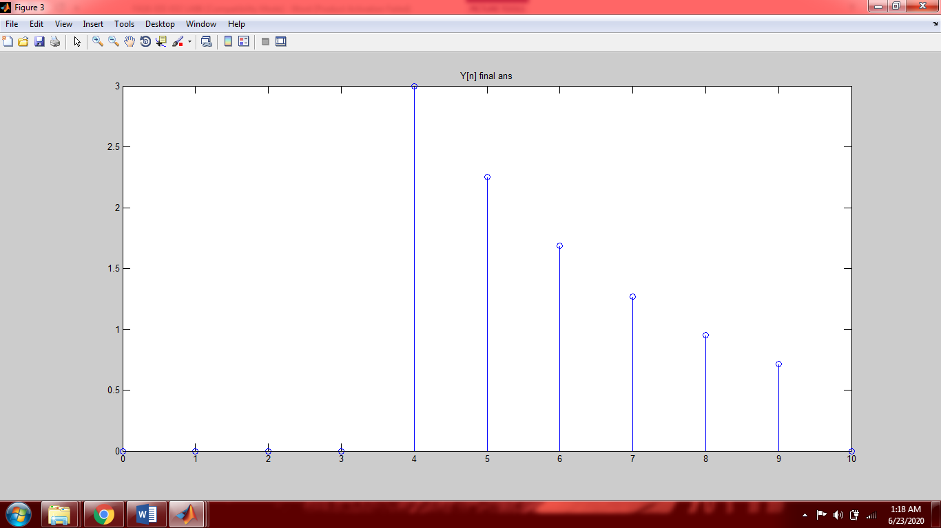

**Post-Lab Tasks**

## Critical Analysis / Conclusion

|  |
| --- |
| In this lab we performed convolution of two discrete time signals. There are two methods to perform convolution in Matlab.  1.Built in function:  There is a built in command in Matlab that allows you to perform convolution of the two signals.  2.Step by step Method:  In this method you have to perform all the steps of convolution i.e. reversal of any one signal, sliding that signal on the first signal and adding all the graphs obtained to get the convoluted signal. This is a very difficult and long method in comparison to the built in function.The trick to easily perform this method is to make the length of both signals equal from the start and then perform the whole procedure.  **According to me the built in function method is much easier to perform because the length of code is small and all you have to do is insert the two signals in the built in function and it will give you the final answer.**  To find the length of the convoluted the signal we have the following formulas   1. Length=length(first signal)+length(second signal)-1   In this formula you have to first figure out the point where the first overlap will take place and make a vector accordingly.   1. n=n1(1)+n2(1) : n1(end)+n2(end)   This formula is much easier because it will make a vector starting from the first overlap and will end at the last overlap. The length of this vector will be equal to the length of the convoluted signal. |